**15-112 Project Proposal**

ID: zhiweny

**Project Description**

Fireboy and Watergirl. This game includes two movable characters, the player will control these two characters and find a way to escape the dungeon. There are some special terrain restrict character movements, and the plater can also collect diamonds along the way to the exit door.

**Similar Projects**

Many different versions of Fireboy and Watergirl are available online, with different game level. Some difficult levels may include more interactive scenes, such as rope and movable boxes. But all these games include two fundamental elements: the larva that only fireboy can go through and the water pool that only watergirl can go through. In this term projects, the game will include these two classic scenes and add one randomly dropping rocks from the ceiling which player have to avoid all the time.

**Structural Plan**

The project will develop under MVC and OOP principles. A class gameboard will contain two elements: Terrain and character. The class terrain consists of different lines (another class) and each line will have its own property. The character class would have two instances: fireboy an watergirl.

**Algorithmic Plan**

The difficult part of this project is how to control characters smoothly jumping and running between different layers of the platform. And we should also consider collision between character and walls, character’s movement on a slopping ground, and moving status of character when it jumps up or jump down a layer. The preliminary idea is the character had an initial falling speed, and it changes when player jump or move. We check at each moment whether there is ground under if yes, set the speed to 0 and if no fall until reach a line. Similar idea will also be used in jumping.

**Timeline Plan**

Finish an easy terrain and characters can make reasonable movements -by 17 Apr

Add player score, timer and refine animation of terrain and characters -by 22 Apr

Complete final code, construct readme file, video demo and zip all -by 26 Apr

**Version Control Plan**

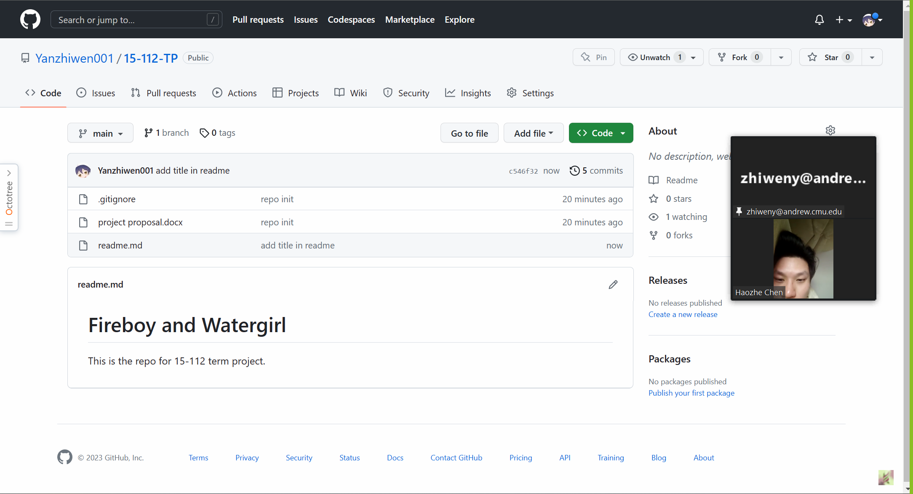

**Module List**

No plan for external module.